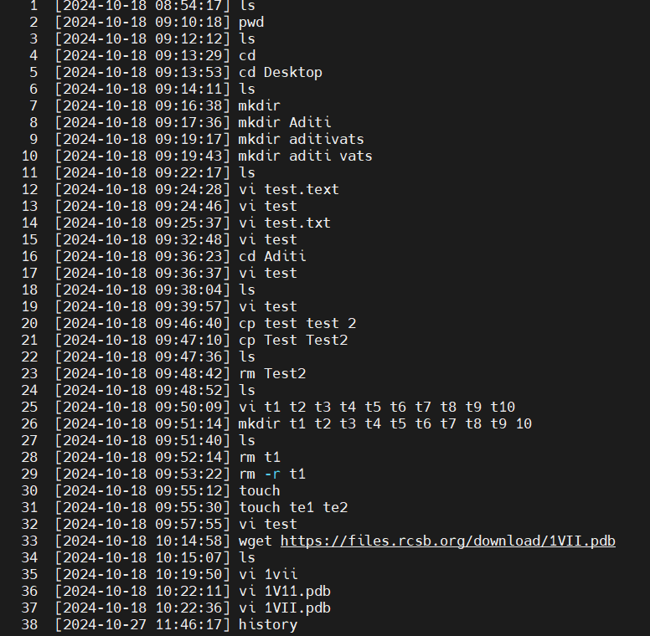

**1. Basic Commands**

* ls: Lists the contents of the current directory.
* pwd: Displays the current directory path.
* cd: Changes the directory. For example:
  + cd Desktop (Line 4): Changes to the Desktop directory.
  + cd Aditi (Line 16): Changes to the Aditi directory.

**2. Directory Management**

* mkdir <directory_name>: Creates a new directory.
  + **Examples:**
    - mkdir Aditi (Line 7): Creates a directory named "Aditi".
    - mkdir aditivats (Line 9): Creates a directory named "aditivats".
    - mkdir t1 t2 t3 t4 t5 t6 t7 t8 t9 t10 (Line 26): Creates multiple directories named "t1" through "t10".

**3. File Management**

* vi <filename>: Opens a file in the vi editor.
  + **Examples:**
    - vi test (Lines 13, 15, and 17): Opens or creates a file named "test".
    - vi test.text (Line 12): Opens or creates a file named "test.text".
    - vi t1 t2 t3 t4 t5 t6 t7 t8 t9 t10 (Line 24): Opens or creates multiple files named "t1" through "t10".
    - vi lvii (Line 34), vi 1VII.pdb (Line 37): Opens or creates files with specific names.  
        
      **(**To create and edit a file named **example.txt**.
    - **Steps:**
    - **Open or Create a File**:

vi example.txt

* • This command will open example.txt in the vi editor. If the file doesn’t exist, vi will create it.

**Entering Insert Mode**:

* In vi, you start in **command mode** (where you can navigate or give commands).
* Press i to enter **insert mode**, which allows you to start typing and editing text.

**Editing Text**:

* Once in insert mode, you can type your content. For example

Hello, this is an example file.

Here is some sample text.

**Saving and Exiting**:

* Press Esc to return to command mode.

Combine these actions by typing :wq and pressing Enter to **save and quit** in one step.

**Discard Changes and Exit**:

* If you made changes you don’t want to save, type :q! and press Enter to **exit without saving**.

* cp <source> <destination>: Copies a file to a specified location.
  + **Example:**
    - cp test test 2 (Line 20): Copies the file "test" to a new file named "test 2".
    - cp Test Test2 (Line 21): Copies the file "Test" to "Test2".
* rm <filename>: Deletes a specified file.
  + **Examples:**
    - rm Test2 (Line 23): Deletes the file "Test2".
    - rm t1 (Line 28): Deletes the file "t1".
* rm -r <directory_name>: Recursively deletes a directory and its contents.
  + **Example:**
    - rm -r t1 (Line 29): Recursively deletes the "t1" directory.
* touch <filename>: Creates an empty file.
  + **Examples:**
    - touch te1 te2 (Line 31): Creates two empty files, "te1" and "te2".

**4. File Downloading**

* wget <URL>: Downloads a file from a specified URL.
  + **Example:**
    - wget https://files.rcsb.org/download/1VII.pdb (Line 33): Downloads a file named "1VII.pdb" from the RCSB PDB website.

**5. Using history**

* The history command (Line 38) lists all previously entered commands in the terminal session. This is particularly useful for recalling past actions.**)**